Execute the following commands in Cassandra CQL Shell:

1. Command to create Keyspace:
cqlsh>CREATE KEYSPACE students1 WITH REPLICATION={ 'class':'SimpleStrategy', 'replication_factor':1};

2. Command to describe the existing Keyspaces:
cqlsh> DESCRIBE KEYSPACES;
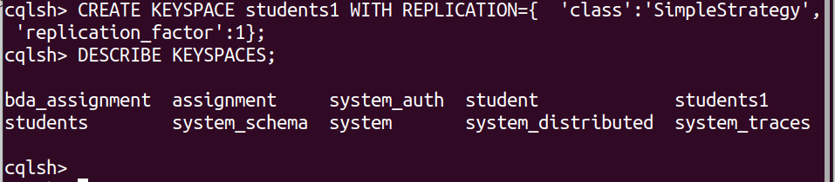

3. Command to get more details on existing keyspaces such as keyspace
name, durable writes, strategy class, strategy options etc.
cqlsh>SELECT * FROM system.schema_keyspaces;

4. Command to use keyspace students:
cqlsh>USE students1;

5. Command to create a column family or table by the name
“Student_Info”.
cqlsh:students1>create table Student_Info(
RollNo int PRIMARY KEY,
StudName text,
DateofJoining timestamp,
LastExamPercent double);

6. Command to look up the names of all tables in current keyspace, or in all keyspaces if there is no current space:
cqlsh:students1> DESCRIBE TABLES;

7. Command to describe the table Student_info:
cqlsh:students1> DESCRIBE TABLE student_info;
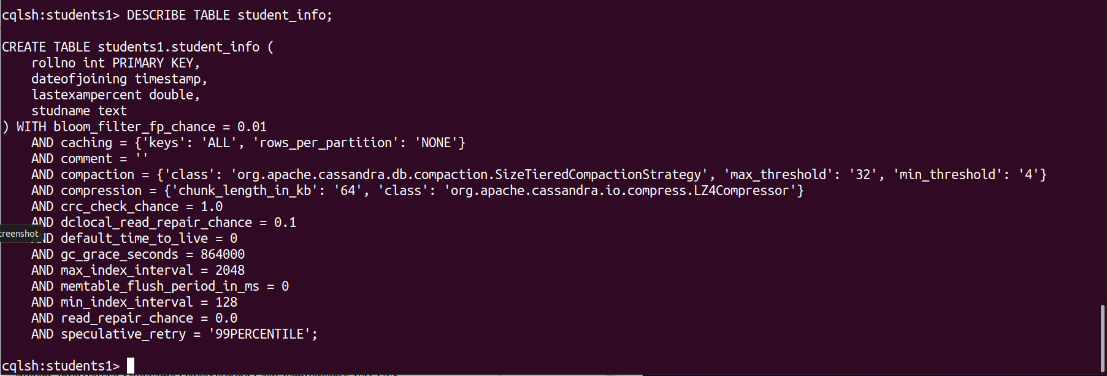

CRUD Operations
1. To insert data into the column family “student_info”.
BEGIN BATCH
INSERT INTO
student_info(RollNo,StudName,DateofJoining,LastExamPercent) VALUES (1,'Michael Storm','2012-03-29', 69.6)
INSERT INTO student_info
(RollNo,StudName,DateofJoining,LastExamPercent) VALUES (2,'Stephen Fox','2013-02-27', 72.5)
APPLY BATCH;

2. To view the data from the table “Student_Info”.
SELECT * FROM Student_Info;
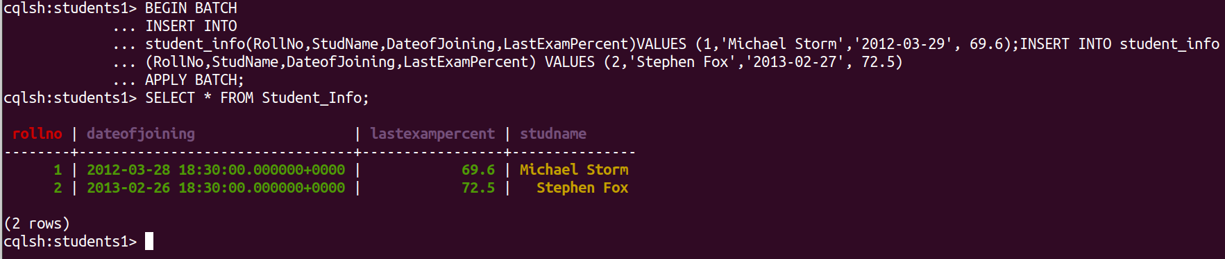

3. To update the value held in the “StudName” column of the “student_info” column family to “David Sheen” for the record where the RollNo column has value = 2.
UPDATE Student_info SET StudName = 'David Sheen' WHERE RollNo = 2;

4. To view only those records where the RollNo column either has a value 1 or 2 or 3.
SELECT * FROM Student_info WHERE RollNo in (1,2,3);
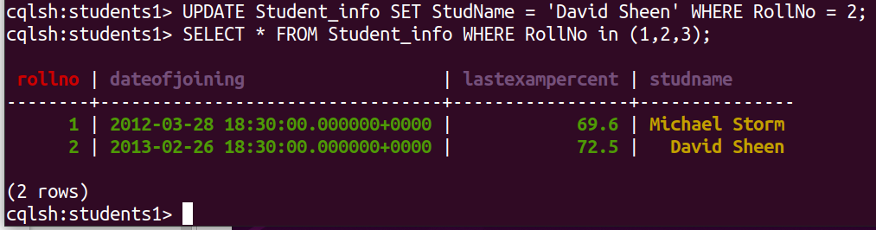

5. To create an index on the “studname” column of the “student_info” column family use the following statement.
CREATE INDEX ON Student_Info(studname);
6. To execute the query using the index defined on "studname" column.
SELECT *
FROM student_info
WHERE studName='Stephen Fox' ;
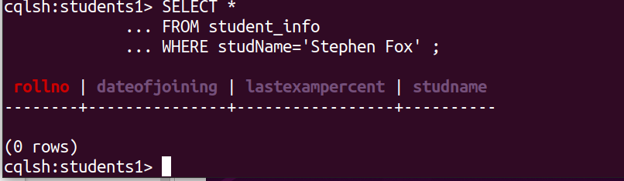
7. To create index on the "LastExamPercent" column of the "Student_Info" column family.
CREATE INDEX ON Student_Info(LastExamPercent);

8. To specify the number of rows returned in the output using limit. SELECT RollNo, LastExamPercent
FROM Student_info LIMIT 2;
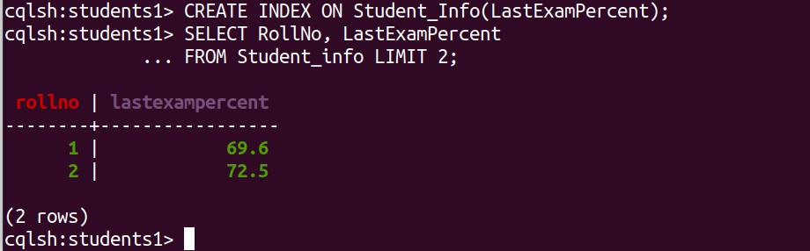
9. To use column alias for the column ‘StudName’ in the Student_Info table.
SELECT RollNo, StudName AS "Name"
FROM Student_Info;
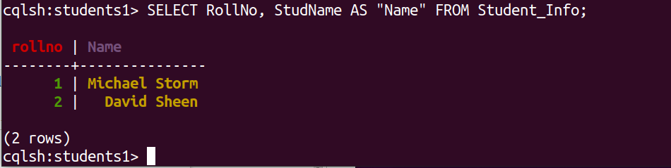
10. To update more than one column of a row of Cassandra table. UPDATE Student_Info
SET StudName=”Samaira”, LastExamPercent=85.7
WHERE RollNo=2;
After the Update:
SELECT RollNo, StudName, LastExamPercent
FROM Student_Info where RollNo=2;
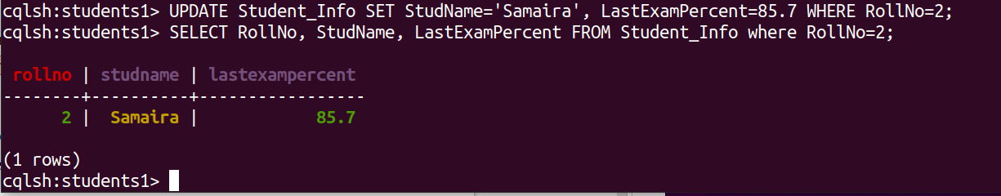

11.To delete the column “LastExamPercent” from the “student_info” table for the record where the RollNo = 2.
DELETE LastExamPercent FROM Student_Info WHERE RollNo=2;
After the Delete:
SELECT *
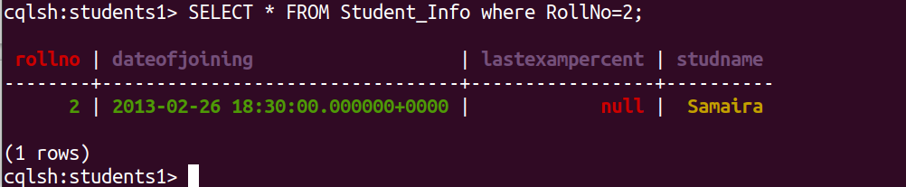
FROM Student_Info where RollNo=2;

12. To delete a row from the table Student_Info.
DELETE FROM Student_Info
WHERE RollNo=2;
After the Delete:
SELECT *
FROM StudentInfo where RollNo=2;
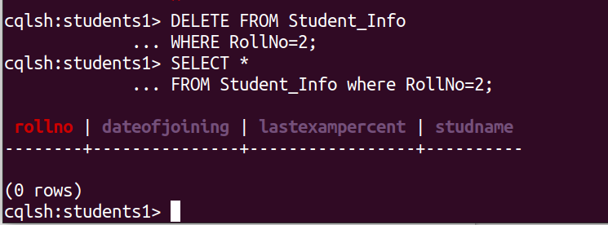

Project Table
1. To create Project Table in students keyspace.
students1> CREATE TABLE PROJECT_DETAILS(
... PROJECT_ID INT,
... PROJECT_NAME TEXT,
... STUD_NAME TEXT,
... RATING DOUBLE,
... DURATION INT,
... PRIMARY KEY(PROJECT_ID, PROJECT_NAME));

2. To Insert data
BEGIN BATCH
INSERT INTO PROJECT_DETAILS(PROJECT_ID, PROJECT_NAME, STUD_NAME, RATING, DURATION)
... VALUES(1,'MS data migration','David Sheen',3.5,720)
... INSERT INTO PROJECT_DETAILS(PROJECT_ID, PROJECT_NAME, STUD_NAME, RATING, DURATION)
... VALUES(1,'MS Data Warehouse','David Sheen',3.9,1440)
... INSERT INTO PROJECT_DETAILS(PROJECT_ID, PROJECT_NAME, STUD_NAME, RATING, DURATION)
... VALUES(2,'SAP Reporting','Stephen Fox',4.2,3000)
... INSERT INTO PROJECT_DETAILS(PROJECT_ID, PROJECT_NAME, STUD_NAME, RATING, DURATION)
... VALUES(2,'SAP BI DW','Stephen Fox',4,9000)
... APPLY BATCH;

3. To view all rows of project_details table.
SELECT * FROM PROJECT_DETAILS
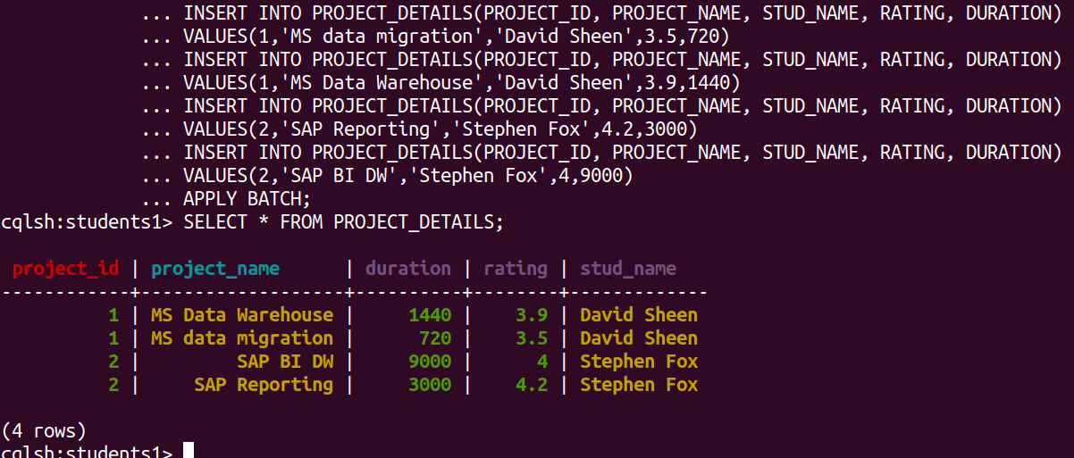
4. To view row/record from the “project_details” table wherein the project_id=1
SELECT * FROM PROJECT_DETAILS WHERE PROJECT_ID=1;
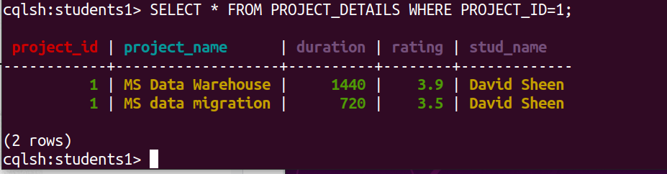

5. To sort order the rows/records of the “project_details” in descending order of project_name.
SELECT * FROM PROJECT_DETAILS WHERE PROJECT_ID IN (1,2);
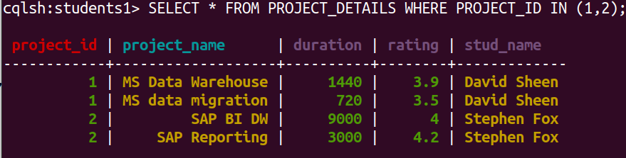
SELECT * FROM PROJECT_DETAILS WHERE PROJECT_ID IN (1,2) ORDER BY PROJECT_NAME DESC;

